**PROJECT DOCUMENTATION**

Project – Real Time Pizza Order Tracking application

Made By – Govardhan VP

Batch – Academy-FSD-November-2021

------------------------------------------------------------------------------------I

I have made a Real-time pizza order tracker website for both desktop & mobile view by using Java-script, Nodejs, express, passportjs for authentication (login & register) ,stripe for payment system, ejs template engine for html files, tailwind CSS for utility first CSS framework, Sass for CSS pre-processor and have Mongo-db data base for this project.

The project will contain following features---

All the data will be stored in mongo DB database and will be retrieved from there only.

**Features:**

Project will have 2 types of user one will be the customer who can order pizza And another will be the admin who will have access to all orders placed by the customer and admin will be responsible for fulfilling the customer’s needs and updating the order details of the customers individually. Here we can also access the website using guest mode but if we want order the pizza we need to login/ register in this website compulsory.

**Customer Do’s**

* Can login/register in the app.

Login

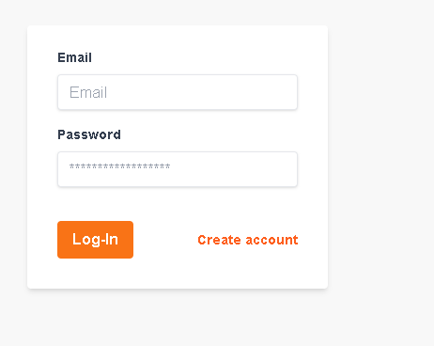

Register

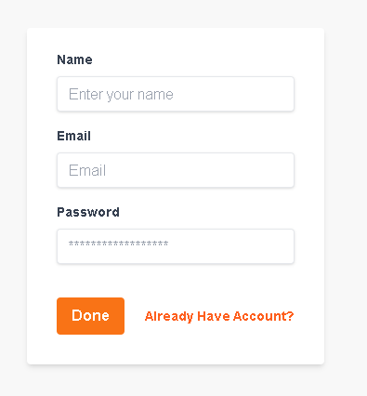

* Can Add items in the cart.

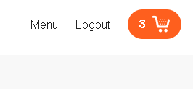

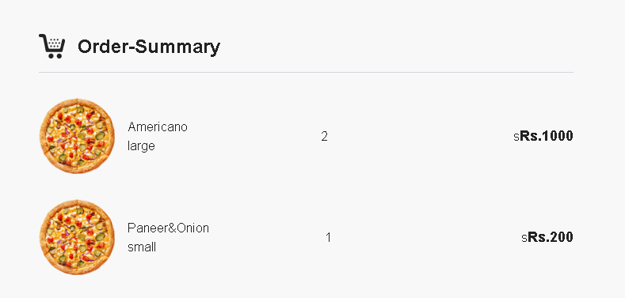

* Can Place order in the app.

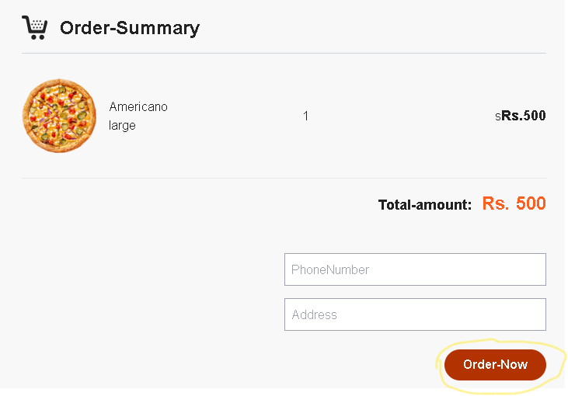

* Can see their full order history.

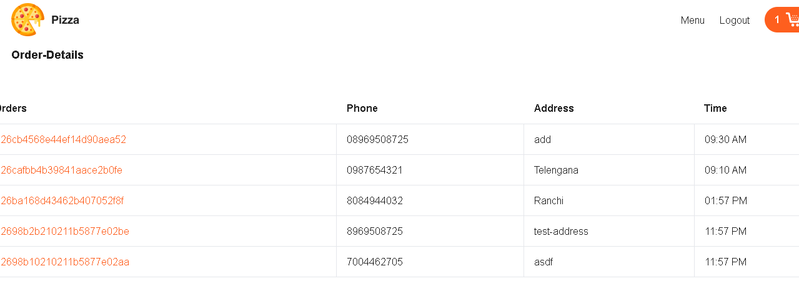

**Customers Can’t**

* A customer cannot access admin order details page
* A customer cannot access other customer’s order details.

Coding and implementation pages are shown below-

* A properMVC project structure has been followed for this project.

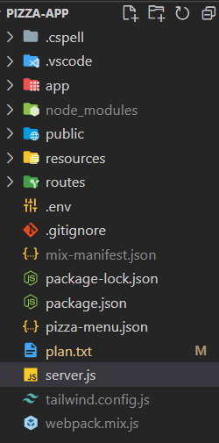

* All the static files are served inside the public folder.
* Tailwind CSS has been used for the Frontend styling part.

**DATA BASE**

* I am using Mongo-DB database for storing the apps data.
* DB name –Govardhan-Pizza. Collections used for storing data are –

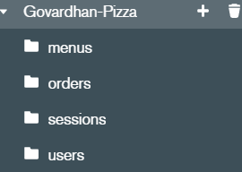

* **Orders –** Contains the details of all the orders placed by the customers with the customer Id and the unique order Id. Here is the example for the same-

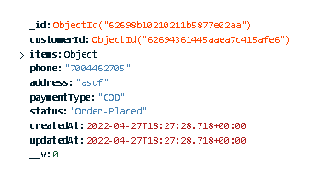

* **Users-** Users contains the collection of all the users who are Registered in the app.

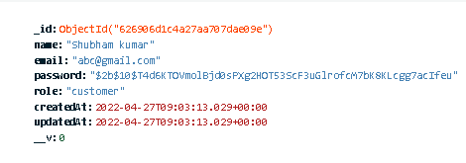

* **Sessions –** Contains the session details
* **I have used Mongoose to create the Schema for storing the data and Mongoose schema is stored in a different file inside models-**

**1. Menus –**

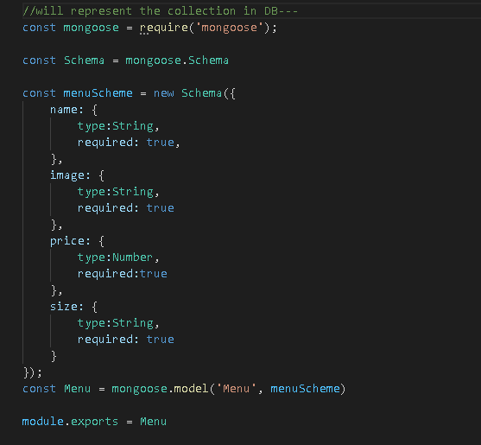

**2. Orders –**

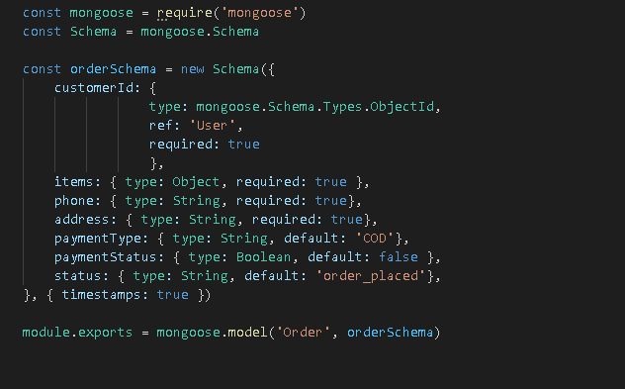

**3.User Schema-**

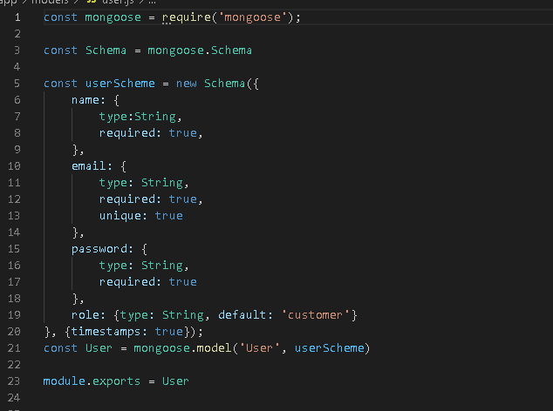

**Authorization**

* **Authorization part is being handled inside the auth-controller.**

>> I have used Bcrypt package for saving the encrypted password in the DB.

>> I have used Passport package to authenticate the requests.

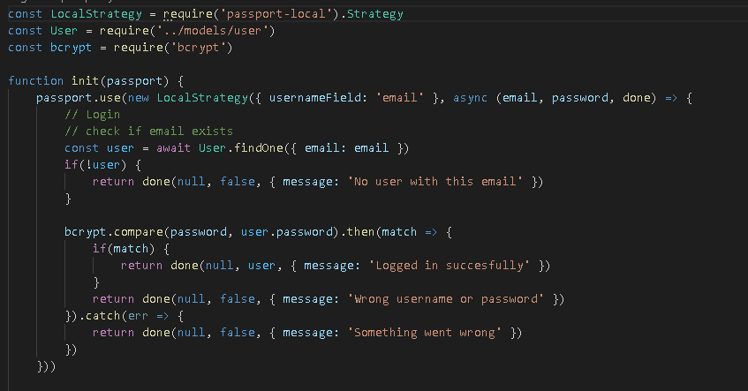

**Routes**

* All The Routes are imported inside the Routes folder in web.js.

**Controllers**

* All the controllers are inside the controllers folder which is inside app/http folder.
* There are 4 controllers in the project-

1. Home-controller- For the Home-Page.

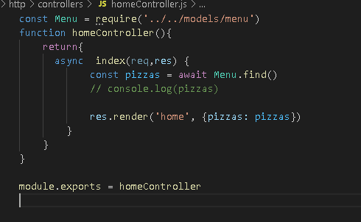

2. **Auth-controller- For handling** authorization/authentication of the project.

**3. Cart Controller-**

This contains all the logic related to adding items in the cart.

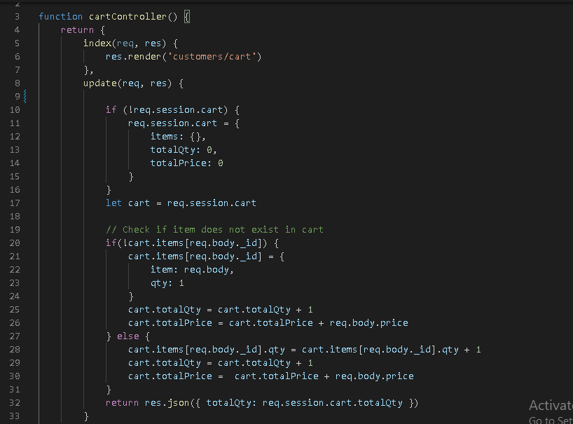

4**. Order Controller**- It has all the logic which handles

This contains all the logic related to placing order & payment type.

